Diagnostic Analysis of Cargo

CapSTONE PROJECT

Daniel Amparo Diaz

[Year]

Initial Model Development

Objective: Diagnostic analysis of the AOG cargo services and exploration of data to uncover reasons behind bottlenecking in services provided.

Data analysis: Diagnostic analysis, Descriptive analysis

The Questions:

* Can diagnostic analysis uncover any correlation between variables?
* Are there any outliers within the data set? What makes them unique, and is there a pattern within these outliners?
* What are the top reasons for bottlenecks within the air cargo supply chain?
* What does the data tell us about who is responsible for the delays in shipments?

**Data Analysis Excel**

Contractual obligations are seven days for routine shipments, five days for Critical, and three days for AOG services. The average transit time chart displays the blue line representing the actual time it took for services to be delivered, while the orange line represents the contractual or expected time for these services by the customer to be delivered. In the AOG and critical sections, the actual transit times are generally higher than the contractual times, indicating delays or longer-than-expected delivery times. In the Routine section, both lines are closer together, suggesting that the actual service delivery closely matches the expectations. The routine section shows less variation, with both actual and contractual times staying relatively close to each other.

The value -0.072248401 represents the correlation coefficient between the "Rated Weight Kg" and the "Actual Transit Time". Since the number is close to zero, it suggests there is a very weak relationship between the two. If the number was closer to 1 or -1, it would indicate a strong relationship, with 1 being a perfect positive relationship (meaning as one increases, the other does too) and -1 being a perfect negative relationship (meaning as one increases, the other decreases).

The negative sign before the number (-0.072248401) indicates that the relationship is negative, but because the number is so small, the negative relationship is very weak. In practical terms, this means that as the rated weight increases, there is a very slight tendency for the actual transit time to decrease, but the effect is so small that it might not be considered significant or may be due to chance.

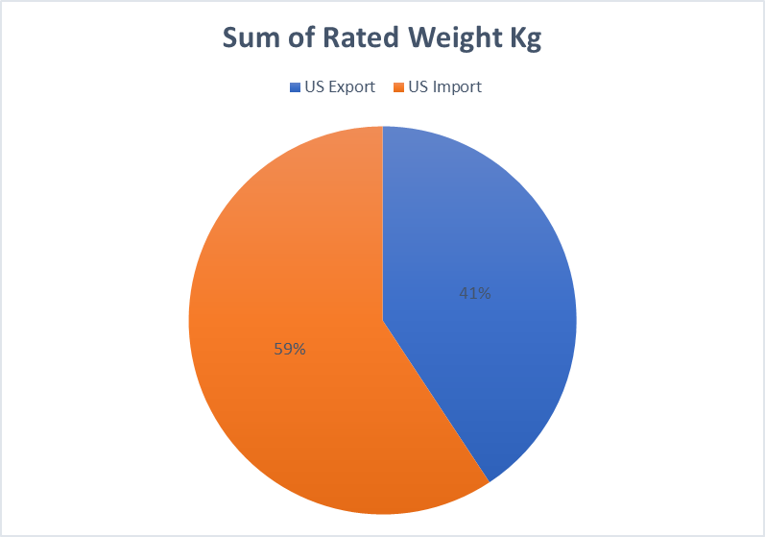

Pie chart displays the volume in weight by business type.

Descriptive Analysis on the services for Air Cargo

Based on the descriptive data, we can conclude a few things we can notice the following:

"Nb of Routine" has a high mean, suggesting that routine events occur frequently.

"Nb of Critical" and "Nb of AOG" have low means, indicating that these events are rare.

The high kurtosis for "Nb of Critical" and "Nb of AOG" suggests that data are heavily concentrated at the tails of the distribution, which is common for rare events.

The skewness values indicate the direction of the skew. For example, "Nb of Routine" is negatively skewed, meaning there are more high values and the distribution tails off to the left.

Note: routine shipments are common, but critical and AOG shipments events are rare and significant when they occur. The OK and KO could indicates compliance (OK) or issues (KO) with certain standards or expectations are not met. Gross OK/KO will have a reason associated with the delay of the shipment. While Net OK/KO will not have reasonings due to the shipment not being reviewed.

**Interpretation of Results from Excel**

U.S. Export

Average of Actual Transit Time: The overall average transit time is 4.4 days, with AOG (Aircraft on Ground) having the shortest average transit time of 3.1 days, indicating a priority in shipping.

Average of Delay (Net): A slight average delay of 0.5 days is noted, with AOG and DAP (Delivered At Place) experiencing slightly higher delays.

Average of Delay (Gross): The average is 0.6 days. The difference between net and gross delay is minimal, which may indicate efficient handling of delays.

Sum of Rated Weight Kg: The total rated weight for U.S. Exports is 101,783.00 Kg.

US. Export

Average of Actual Transit Time: The average transit time is notably higher for imports at 8.0 days, with Critical and Routine shipments taking the longest times, 8.3 and 8.0 days.

Average of Delay (Net): The delays for imports are notably higher than exports, averaging 1.7 days. Critical shipments experience the highest delays at 3.2 days.

Average of Delay (Gross): Gross delays mirror the pattern of net delays, with the highest delays seen in Critical shipments.

Sum of Rated Weight Kg: The total rated weight for U.S. Imports is significantly higher than exports at 148,245.00 Kg. It's interesting to note that Critical and Routine shipments have the same weight, which may imply they are related or part of a bulk shipment that's been categorized differently based on urgency or other factors.

Summary of Results

Transit Times: Imports take almost twice as long as exports in terms of transit time. This could be due to longer distances, different modes of transportation, or more complex import procedures.

Delays: Imports are more prone to delays than exports, with critical shipments being the most affected. This suggests that while these shipments are deemed urgent, they might be facing systemic inefficiencies or other issues that need addressing.

Weight Distribution: There's a vast difference in the weight of goods being imported vs. exported, which could indicate a trade imbalance or that different types of goods are being moved. Bulk of the shipments are importing may be the reason there is a higher delay for those services.

Missing Data: Some cells, particularly under the U.S. Export section for CPT, EXW, and FCA, are missing data for delays and weight. This incomplete data could skew the overall analysis and should be addressed for a more accurate assessment. Along with miss coding or systems errors when inputting shipment information.

**Python Analysis**

Based on the analysis using the 'Service' column, here are the findings regarding the average time of delivery and delays for different service shipments:

AOG (Aircraft on Ground) Service:

Average Delivery Time: Approximately 3.71 days. Average Net Delay: Approximately 0.71 days. Average Gross Delay: Approximately 0.86 days. Critical Service:

Average Delivery Time: Approximately 10.92 days. Average Net Delay: Approximately 2.92 days. Average Gross Delay: Approximately 2.92 days. Routine Service:

Average Delivery Time: Approximately 10.97 days. Average Net Delay: Approximately 1.43 days. Average Gross Delay: Approximately 1.59 days. These results provide insights into the performance of different service types in terms of delivery times and delays. AOG service, typically used for urgent shipments, shows the shortest delivery time, while Critical and Routine services have longer delivery times and higher delays.

The bar chart compares the average depth of delay between "US Import" and "US Export". As observed, there's a quantifiable difference in the average depth of delay, with "US Import" experiencing a different level of delay compared to "US Export".

While this visualization helps understand the impact of delays on imports vs. exports, it does not directly address the top 5 reasons for delays due to the lack of explicit data on delay reasons. To delve deeper into the reasons, we would typically analyze textual data, customer feedback, or specific incident reports, which are not available in the current dataset.

AOG (Aircraft on Ground):

This is typically a high-priority service type, as indicated by the significant average delivery time. The net delay is relatively lower compared to the gross delay, which might indicate that while there are delays, they are often resolved quickly due to the urgency of AOG situations.

Critical:

This service type has a lower average delivery time compared to AOG, which is expected as "critical" may not always be as urgent as AOG. Both net and gross delays for critical shipments are lower than for AOG, suggesting better handling or fewer issues causing delays.

Routine:

The routine service type shows the longest average delivery time, which makes sense as these are not prioritized over AOG or Critical shipments. The gross delay is significant, but the net delay is considerably smaller, which could indicate effective delay mitigation strategies are in place for routine shipments.

Interpreting Gross vs. Net Delay:

Gross Delay may represent the total time shipments are delayed without considering any mitigation or recovery efforts. Net Delay likely represents the actual impact of the delay on the delivery time after any mitigation efforts have been made to resolve the delay.

US Import business type has a higher average depth of delay compared to US Export.

This insight suggests that shipments categorized under US Import tend to experience slightly more significant delays than those categorized under US Export, according to the dataset's available information.

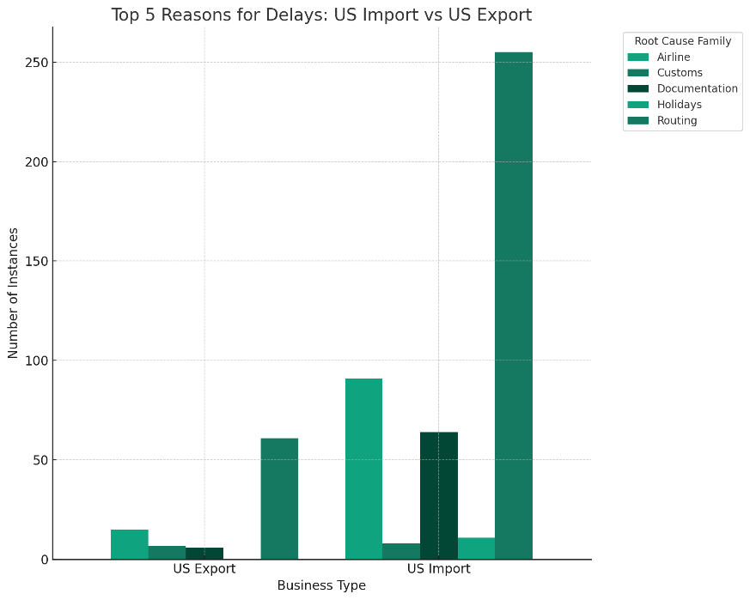

The analysis of Column AV, identified as "Root Cause Family," reveals the top 5 reasons for delays:

* Routing: 316 instances
* Airline: 106 instances
* Documentation: 70 instances
* Customs: 15 instances
* Holidays: 11 instances

These reasons provide insight into the primary factors contributing to shipment delays. To further analyze, we can compare how these top reasons distribute between "US Import" and "US Export".

The bar chart visualizes the incidence of the top 5 reasons for delays across "US Import" and "US Export" business types. This comparison provides valuable insights into the different operational challenges faced by imports versus exports, highlighting the specific areas where delays are most frequent.

From the chart, you can see how each reason for delay is distributed between the two business types, offering a clearer picture of operational areas that may need attention or improvement to reduce future delays.

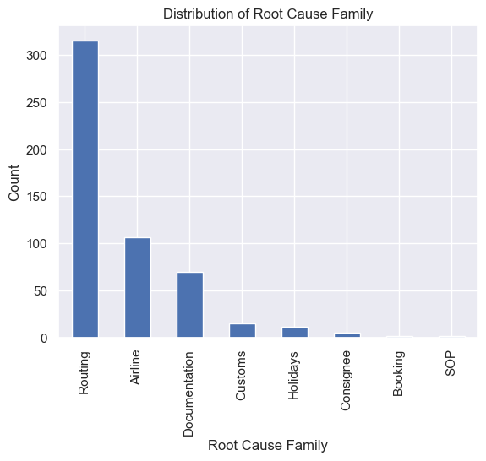delays insights by service – root cause:

A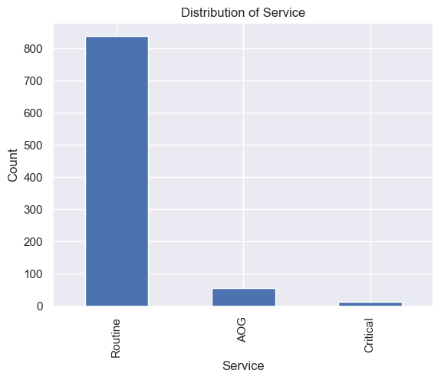

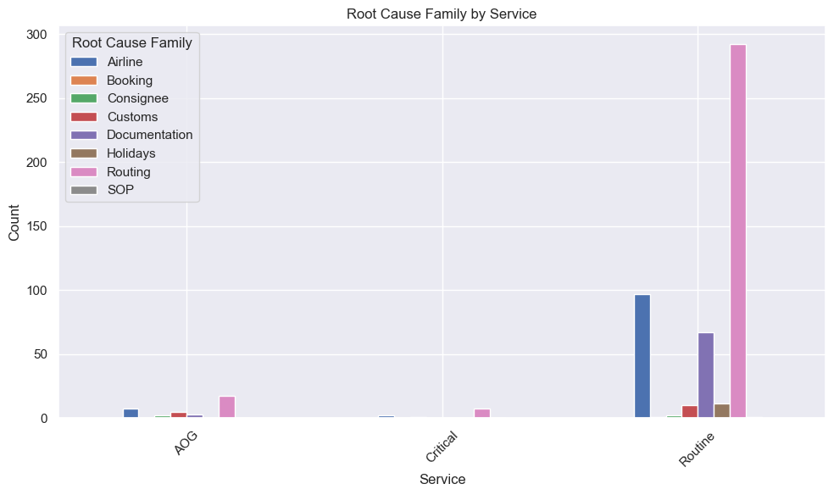

**Analysis of Root Cause:**

Service Variation: There are three distinct services shown in the chart: AOG, Critical, and Routine. The number of incidents varies significantly among these services, with Routine having the highest count.

Dominant Root Causes: For the Routine service, the dominant root cause is 'Routing', which has a significantly higher count compared to other root causes within the same service category. This suggests that routing issues are a major concern for routine services.

Balanced Distribution: In contrast, the Critical service shows a more balanced distribution among the root causes. 'Routing' and 'Customs' are the most frequent root causes, but other categories like 'Airline', 'Booking', and 'Documentation' also contribute to the overall count.

Least Affected Service: The AOG service has the least number of root cause incidents recorded in this dataset. This could indicate a more robust process, or it might simply be a less frequently used service.

Minimal Influence: Some root causes like 'Holidays' and 'SOP' have a minimal influence across all services, suggesting that these are not common issues or are well-managed within the operational processes.

Potential Areas for Improvement: The chart highlights potential areas for improvement, particularly in addressing 'Routing' issues in Routine services and 'Customs' and 'Routing' for Critical services.

Absence of Issues: There are no recorded incidents for some combinations, such as 'Holidays' for AOG and Critical services. This might indicate that operations during holidays are well-handled for these urgent service types.

Data Representation: It's important to note that the y-axis is cut at 300, which means if any categories exceed this count, they are not fully visible. Therefore, we should ensure that the axis limits are set to accommodate the highest count to avoid misinterpretation.

Operational Focus: The company could focus on improving 'Routing' and 'Customs' processes, as these appear to be the most frequent root causes of issues, especially for Routine and Critical services.

**Conclusion**

Based on the raw data and analysis conducted these are my conclusions on my findings:

1. Service Distribution:

The 'Routine' service experiences the highest volume of cases, which could be a factor in why it has the most delays.

2. Root Cause Analysis by Service:

For 'Routing' is the predominant cause of delays in the 'Routine' service. This suggests that there may be systemic issues with logistics or planning within this service line.

For 'Critical' services, the delays are more evenly distributed across 'Airline', 'Booking', 'Customs', and 'Documentation'. This could indicate that there are multiple areas where improvements could be made to reduce delays.

3. Business Type Delay Analysis:

For 'US Import' has significantly more delays than 'US Export', particularly due to 'Customs' and 'Routing'. This might suggest that there are inefficiencies or regulatory challenges associated with importing goods into the US.

4. Average Metrics by Service Type:

For 'Routine' services have a high average delivery time and the highest average net and gross delays. Given the volume of 'Routine' services, this could be a major area for operational improvements.

For 'AOG' services have the lowest average delivery time and delay, likely due to the urgency associated with AOG (Aircraft on Ground) which often requires immediate action.

'Critical' services have an average delivery time and delay between 'AOG' and 'Routine'. It may benefit from reviews of the processes to identify any bottlenecks.

5. Average Depth of Delay by Business Type:

'US Import' has a deeper average delay compared to 'US Export'. This suggests that when delays occur for US Imports, they are more severe than for exports. This may call for a targeted strategy to streamline the import process and reduce the impact of delays.

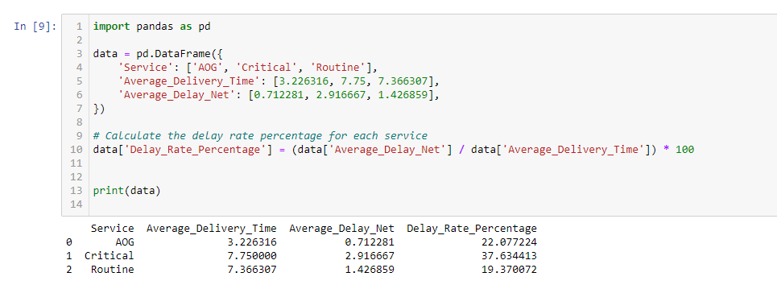

Critical services have the highest likelihood of experiencing delays, with a delay rate percentage of approximately 37.63%. This suggests significant room for improvement.

AOG services follow with a delay rate percentage of about 22.08%. While this is lower than critical services, any delay in AOG can be costly and should be minimized.

Routine services have the lowest observed delay rate at around 19.37%, indicating a relatively better performance but still with potential for further improvement.

**Recommendations**

* Investigate the 'Routing' and 'Customs' processes in depth for 'Routine' services and 'US Imports' to identify specific bottlenecks and areas for improvement.
* Implement stricter time management and process optimization for 'Critical' services to reduce the spread of delay causes.
* For 'AOG' services, continue to prioritize rapid response while examining any potential for even marginal improvements without compromising service speed.
* Consider additional staff training, process automation, or collaboration with customs and regulatory agencies to streamline operations, particularly for 'Routine' services and 'US Imports'.
* Regularly review and adjust operational plans to manage and mitigate the identified root causes of delays.

These conclusions and recommendations should be further validated with additional data analysis, potentially including qualitative feedback from customers and employees, to ensure comprehensive operational improvements.